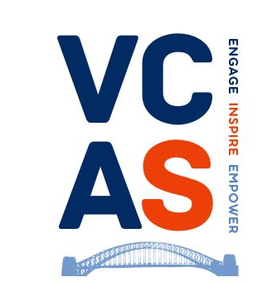

Equality & Diversity Monitoring Form
(Confidential – For Monitoring Purposes Only)
VCAS is committed to promoting equality, valuing diversity, and ensuring fair treatment for all applicants.
Completion of this form is voluntary. The information you provide is anonymous, confidential, and used only for statistical monitoring in line with UK GDPR and the Data Protection Act 2018.

1. Sex (as registered at birth)
☐ Female
☐ Male
☐ Intersex
☐ Prefer not to say

2. Gender Identity
How would you describe your gender identity?
☐ Woman
☐ Man
☐ Non-binary
☐ Another identity (please specify): ______________________________
☐ Prefer not to say
Is your gender identity the same as the sex you were assigned at birth?
☐ Yes
☐ No
☐ Prefer not to say

3. Sexual Orientation
☐ Heterosexual / Straight
☐ Gay / Lesbian
☐ Bisexual
☐ Asexual
☐ Another orientation (please specify): ___________________________
☐ Prefer not to say

4. Age
☐ 16–24
☐ 25–34
☐ 35–44
☐ 45–54
☐ 55–64
☐ 65+
☐ Prefer not to say

5. Marital or Civil Partnership Status
☐ Single
☐ Married
☐ In a civil partnership
☐ Divorced
☐ Widowed
☐ Separated
☐ Prefer not to say
☐ Another status (optional): ____________________________________

6. Ethnic Group
(Using ONS 2021 standard categories)

White
☐ English, Welsh, Scottish, Northern Irish or British
☐ Irish
☐ Gypsy or Irish Traveller
☐ Roma
☐ Any other White background (please specify): ____________________

Mixed or Multiple Ethnic Groups
☐ White and Black Caribbean
☐ White and Black African
☐ White and Asian
☐ Any other Mixed or Multiple background (please specify): ________

Asian or Asian British
☐ Indian
☐ Pakistani
☐ Bangladeshi
☐ Chinese
☐ Any other Asian background (please specify): ____________________

Black, Black British, Caribbean or African
☐ African
☐ Caribbean
☐ Any other Black background (please specify): ____________________

Other Ethnic Group
☐ Arab
☐ Any other ethnic group (please specify): ________________________
☐ Prefer not to say

7. Disability
Under the Equality Act 2010, a disability is a physical or mental impairment that has a substantial and long-term impact on your ability to carry out normal day-to-day activities.
Do you consider yourself to have a disability or long-term health condition?
☐ Yes
☐ No
☐ Prefer not to say
If yes, you may tell us the nature of your disability (optional):

8. Working Status
Which best describes your current situation?
☐ In paid employment
☐ Self-employed
☐ In education or training
☐ Volunteering
☐ Homemaker / caring responsibilities
☐ Currently not working
☐ Retired
☐ Prefer not to say
If you are in paid work, what is your employment pattern?
☐ Full-time
☐ Part-time
☐ Zero-hours
☐ Fixed-term
☐ Temporary
☐ Prefer not to say

