
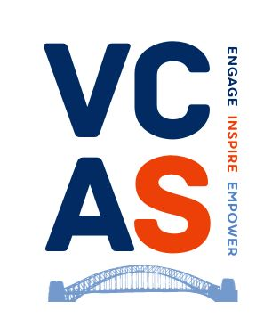

Voluntary and Community Action Sunderland

Sunderland VCSE Volunteering Summit 2026
Volunteering Futures: Co-Designing a Stronger Sector for Sunderland
Hosted by VCAS
Thursday 14 May – Hope Vineyard, Hendon Road SR1 2HX

9:30 – 9:50 | Registration, Refreshments & Networking
Tea/coffee • Conversation-starter cards • Volunteer stories on screen • Early networking

10:00 – 10:20 | Welcome & Opening Remarks
Speaker: Janette Hilton, VCAS
Purpose of the day • Why volunteering matters • Links to NAVCA/NCVO • Invitation to open discussion

10:25 – 10:45 | Keynote 1 – The Regional Picture
Speaker: Martin Brookes, VONNE
Regional data • Post-pandemic shifts • Small-org challenges • Funder/system priorities

10:50 – 11:10 | Keynote 2 – Doing Volunteering Better
Speaker: Vicki Smith, VODA
Volunteer experience • Barriers • Inclusion • What infrastructure bodies can improve

11:15 – 11:35 | Panel Discussion – “What’s Working, What’s Not?”
Panellists: Martin Brookes • Vicki Smith • Amanda Lowery • Joel/Stephen Armstrong • Charlie Lamb • Heritage rep
Facilitator: Steve
Recruitment • Complex needs • Youth volunteering • Burnout • What orgs need from an LIO • Audience Q&A

11:40 – 12:10 | Workshop 1 – What Volunteers Need
Extended to 30 minutes
Motivations • Barriers • Inclusion • Wellbeing • What “good support” looks like
Output: Each table identifies 3 priority needs

12:15 – 12:45 | Workshop 2 – What Organisations Need to Support Volunteers
Extended to 30 minutes
Training • Systems • Induction & retention • Role design • Recognition • Peer networks
Output: Each table identifies 3 capacity-building priorities

12:50 – 1:20 | Lunch & Networking
Optional topic tables: Youth volunteering • Systems • Wellbeing • Micro-volunteering • Corporate volunteering

1:25 – 1:40 | Keynote 3 – Data for Change (15 minutes)
Speaker: Dr Robin Finlay
Building confidence with data • Data for Change • Evidence for funding • Opportunities for Sunderland VCSE

1:45 – 2:00 | Keynote 4 – Another Way of Working (15 minutes)
Speaker: Lesley Scott, PCPI
Is it volunteering? • PCPI model • Lived-experience contributions • Learning from case studies

2:05 – 2:40 | Workshop 3 – Designing a Better Local Volunteering Ecosystem
Extended to 35 minutes
What a local support system should provide • Shared resources • Role of LIO • Role of SCC/funders/partners
Output: Top 5 system-level priorities • Quick wins vs long-term changes

2:45 – 3:00 | Plenary & Closing Remarks
Table insights • Synthesised themes • Shared priorities • Next steps • Invitation to working groups • Thanks

